**Advance Excel Assignment 18**

1. What are comments and what is the importance if commenting in any code?

Ans. Comments are text notes added to the program to provide explanatory information about the source code. They are used in a programming language to document the program and remind programmers of what tricky things they just did with the code and also helps the later generation for understanding and maintenance of code. The compiler considers these as non-executable statements. Different programming language uses a different way of including the comments in the source code.

Comments can be used for the various purpose like :

Planning and reviewing : In comments, we can write the pseudocode which we planned before writing the source code. Pseudocode is a mixture of natural language and high-level programming language. This helps in reviewing the source code more easily because pseudocode is more understandable than the program.

Code description : Code description is used by the programmer to make others understand his/her intent. It contains the summary of the code.

Algorithmic description : Comments are used for explanation of the methodology. Such explanations may include diagrams and formal mathematical proofs. This may constitute the explanation of the code, rather than a clarification of its intent. For example, a programmer may add a comment to explain why an insertion sort was chosen instead of a quicksort, as the former is, in theory, slower than the latter.

Resource inclusion : Logos, diagrams, and flowcharts consisting of ASCII art constructions can be inserted into source code formatted as a comment. Further, copyright notices can be embedded within source code as comments.

Metadata : Comments also contain metadata of the program. This metadata helps in software maintenance. The metadata includes the name of the creator of the original version, current maintainer of the program, data when the first version was created, the name of the people who have edited the program files so far etc.

Debugging : Brute force method is a common method of debugging. In this approach, print statements are inserted throughout the program to print the intermediate values with the hope that some of the printed values will help to identify the errors. After doing debugging we comment those print statements. Hence comment is also used for debugging.

Automatic documentation generation : Programming tools sometimes store documentation and metadata in comments. These may include insert positions for automatic header file inclusion, commands to set the file’s syntax highlighting mode, or the file’s revision number. These functional control comments are also commonly referred to as annotations. Keeping documentation within source code comments is considered as one way to simplify the documentation process, as well as increase the chances that the documentation will be kept up to date with changes in the code.

Stress relief : Commenting on development tools, competitors, employers, working conditions, or the quality of the code itself are the ways to relieve stress. The occurrence of this phenomenon can be easily seen from online resources that track profanity in source code.

1. What is Call Statement and when do you use this statement?

Ans. The CALL statement transfers control from one object program to another within the run unit. The program containing the CALL statement is the calling program; the program identified in the CALL statement is the called subprogram. Called programs can contain CALL statements; however, only programs defined with the RECURSIVE clause can execute a CALL statement that directly or indirectly calls itself.

1. How do you compile a code in VBA? What are some of the problems that you might face when you don’t compile a code?

Ans.

* [Download the VbaCompiler for Excel](https://vbacompiler.com/download/)**on your computer.**
* **Install the VbaCompiler for Excel.** To install the product you need to start VbaCompiler4Excel.msi file and follow the installer steps.
* **Enable “Trust access to the VBA project object model” MS Excel option by following the path:** Excel Options >> Trust Center >> click button “Trust Center Settings…” >> Macro Settings >> enable check box “Trust access to the VBA project object model”
* **Examine your VBA code for syntax errors.**

To do that you need to run the embedded Visual Basic code analyzer, located by following this path:  
VBA Project window (Alt + F11) >> Main menu >> Debug >> Compile VBA project

if after running “Compile VBA Project” Excel found a syntax error, then you need to fix it and  
repeat this step again until the “Compile VBA Project” menu item is greyed out.

**IMPORTANT NOTE:** When you have finished this step your VBA code is not compiled yet.

* **Make backup copy of the file you are going to compile.**

The simplest way of doing this is to copy the file into another folder on your computer.  
**NOTE:** The VbaCompiler for Excel doesn’t change your original file.  
However it is a good practice to have a backup copy of your original file.

* **Remove the VBA Project password in the file you are going to compile.**

You can apply it later, on to the VBA Project of the file with the compiled VBA code.  
This step is required because the VbaCompiler has to get full access to the VBA code.

* **Run VbaCompiler for Excel by clicking the shortcut on the Windows desktop.**
* **Enter the name of file you want to compile.**

The easiest way is to select the file by clicking the […] button which is next to edit field and selecting the file in the dialogue window.

* **Enter the output folder where resulting files/modified excel file and Windows DLL with compiled VBA code will be located after compilation.**

The easiest way is to select a folder by clicking the […] button which is next to edit field and selecting the folder in the dialogue window.  
You can find  each compilation option meaning at the [VBA Compiler options](https://vbacompiler.com/vba-compiler-options/) page.

* **Click the ‘Compile’ main menu item and wait until VBA code compilation is finished.**

1. What are hot keys in VBA? How can you create your own hot keys?

Ans. A hot key is a key or a combination of keys on a computer keyboard that, when pressed at one time, performs a task (such as starting an application) more quickly than by using a mouse or other input device. Hot keys are sometimes called shortcut keys. Hot keys are supported by many operating system and applications.

Begin keyboard shortcuts with CTRL or a function key :

1. In the Press new shortcut key box, press the combination of keys that you want to assign. For example, press CTRL plus the key that you want to use.
2. Look at Current keys (or Currently assigned to) to see whether the combination of keys is already assigned to a command or other item. If the combination is already assigned, type a different combination.
3. Select Assign.
4. Create a macro and shortcut key to find the square root of the following numbers 665, 89, 72, 86, 48, 32, 569, 7521

Ans.

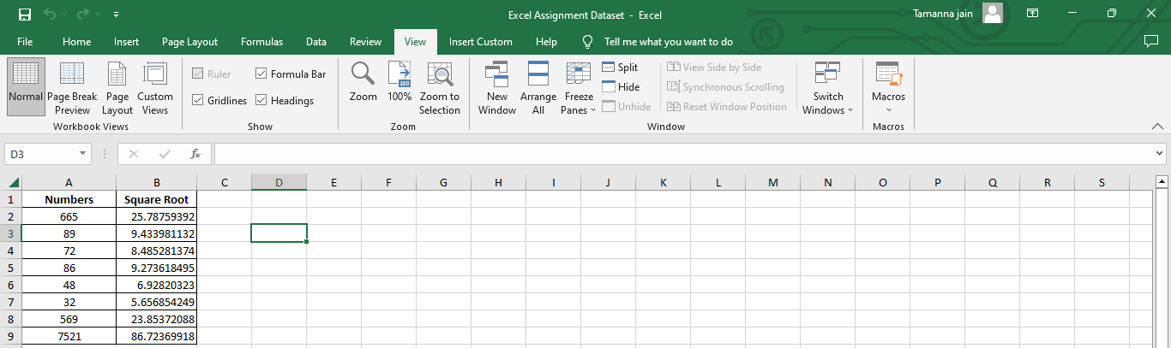

Ctrl+s is the short key I assigned for calculating the sqrt.

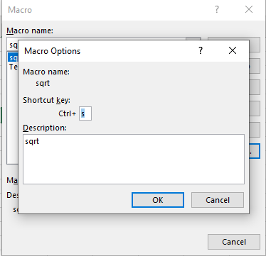

1. What are the shortcut keys used to

a. Run the code

b. Step into the code

c. Step out of code

d. Reset the code

Ans. a. Run the code : Alt+F8

b. Step into the code : F5

c. Step out of code : ctrl + Shift + F8

d. Reset the code : Alt,R,R